|  |
| --- |
| Functional Specification Document  <Holidaze > |

**DOCUMENT VERSION <Version-1>**

**<06-05-2020>**

**AUTHORS**

|  |  |  |
| --- | --- | --- |
| **Name** | **Role** | **Department** |
| Mohammed Faisal Hameed | Front-end Developer | Web Development |

**DOCUMENT HISTORY**

|  |  |  |  |
| --- | --- | --- | --- |
| **Date** | **Version** | **Document Revision Description** | **Document Author** |
| 06-05-2020 | V1 | Draft Version | Mohammed Faisal Hameed |
|  |  |  |  |
|  |  |  |  |
|  |  |  |  |
|  |  |  |  |

**APPROVALS**

|  |  |  |  |
| --- | --- | --- | --- |
| **Approval Date** | **Approved Version** | **Approver Role** | **Approver** |
| 06-05-2020 | V1 | Development Team Leader |  |
|  |  |  |  |
|  |  |  |  |

# Introduction

Holidays is a local tourism agency in Bergen. The Agency enable visitors to find hotels, B&Bs and guesthouses, and for the accommodation owners to receive enquiries.

# Purpose of the document

# 

# The purpose of this document is to document the business requirements and functional rules of the Holidays website. This document will include a basic mockup of the website.

# All system requirements and restraints will be documented.

# Risks and Assumptions

|  |  |  |  |
| --- | --- | --- | --- |
| **Risk** | **Level** | **Impact** | **Responsible** |
| User logins will not be migrated to the new portal | High | Users will not be able to login in using their existing login details | Development Team |

# System/ Solution Overview

# Functional Specifications

### 

### Develop an online site

### 4.1 Purpose/ Description

## Develop an online site that for advertising and booking Hotel, B&B and Guesthouses

### Use case

|  |  |
| --- | --- |
| **UC-1** | **Advertising and booking** **Hotel, B&B and Guesthouses** **where customers can manage their bookings online.** |
| **Primary Actor(s)** | Customers |
| **Stakeholders and Interest** | CEOBusiness Owner |
| **Trigger** | Create a website |
| **Pre-conditions** | Website does not exist |
| **Post-conditions** | URL of website to exist |
| **Main Success Scenario** | Enter one of Holidaze’s landing pages or enter the website.Search by filtering out Hotel, B&B and Guesthouses by pricing etc.A confirmation for successful/ unsuccessful search is displayed. |
| **Extensions** | If URL does not work, try google search for Holidaze. |
| **Priority** | High |
| **Special Requirements** | A domain name and host to exist |
| **Open Questions** | <Notes and questions> |

# 5. Mock-up

**

1. Prototype Explanation

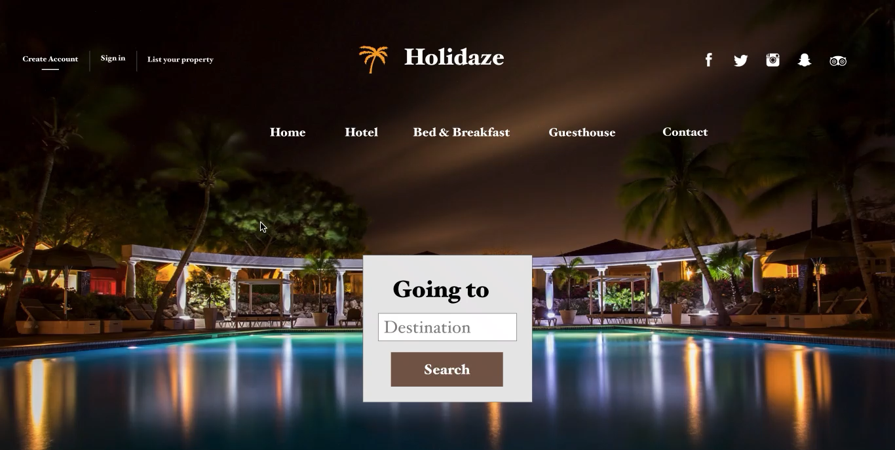Click below to watch explanation Video